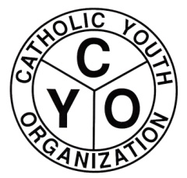

CYO DIOCESAN TRACK LEAGUE
2021 OUTDOOR SEASON TEAM REGISTRATION FORM

MEETS
CYO SUNDAY SPRINT: SUNDAY, 5/16/2021
WARRREN SCULLIN MIDDLE DISTANCE: SUNDAY, 5/23/2021
RAY SUAREZ RELAY CARNIVAL: SUNDAY, 6/6/2021
RAIN DATE : SUNDAY, 6/13/201
CHECK IN IS 12:30 PM -- FIRST RACE IS 1:00 PM.

PARISH/TEAM NAME: _______________________________________________

BOYS:__________ GIRLS:___________ (Check one or both)

COACH NAME AND ADDRESS: __________________________________________
(Please print) __________________________________________
__________________________________________
PHONE NUMBER: __________________________________________
E-MAIL ADDRESS:
We hereby certify that the competitors submitted to CYO on our roster are eligible to represent the parish in accordance with the Rules and Regulations of CYO.

COACH/AD SIGNATURE DATE

THIS FORM IS TO BE MAILED, FAXED OR EMAILED TO THE CYO OFFICE AS SOON AS POSSIBLE BUT NO LATER THAN MONDAY 5/10/2021.

CYO DIOCESE OF BROOKLYN
IMMACULATE CONCEPTION CENTER
7200 DOUGLASTON PARKWAY
DOUGLASTON, NY 11362
ATTN: KEITH GOLDBERG
FAX: 718-281-9557
KGOLDBERG@DIOBROOK.ORG

